[Date]
[Member/Widow’s Name]
[Member/Widow’s Address]

Dear [First Name]

Greetings – I hope that this letter finds you well!

It has been brought to my attention by a concerned member of our fraternal family that you may be interested in Masonic Outreach Services, or that some of our assistance might be useful to you at this time.

Enclosed is a summary of the resources available to you through your fraternity. If any of these services are of interest to you, or if you have any questions regarding the services or your eligibility, please contact Masonic Assistance at (888) 466-3642 or at masonicassistance@mhcuc.org. You may also wish to review the information on our website, masonichome.org. Feel free to share this information with your family so that they can assist you with accessing the services you need.

The Masonic Homes of California was created to support fraternal family members in their hour of need. If these services can improve your quality of life, I encourage you to contact us to learn more.

Best regards,

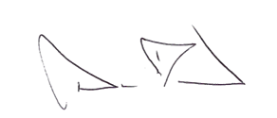

David Blood
Associate Director
Masonic Assistance and Outreach
34400 Mission Boulevard
Union City, CA 94587-3604

[Note to sender: Along with this letter, be sure to attach Member Benefits Overview and Getting Started with Masonic Assistance.

